**PURPOSE**

Use this procedure to enter/edit **Physical Fitness Test (PFT)** scores in MiSiS for enrolled students in grade levels 4-12. The screen will be available for grades 5, 7, and 9 only during the **PFT** testing window; please note that data entry will not be available during the summer break.

The State Board of Education designated the FITNESSGRAM as the **PFT** for students in California public schools. **All** students in grades 5, 7, and 9 must take the FITNESSGRAM each Spring. **Please Note:** The State Board of Education has omitted the Body Composition component of the PFT for the 2021-22 school year.  Schools are not required to test students for this component.

WHO CAN PERFORM THE TASK(S)

* **School-Based roles:** Principal, PE Teacher, Office Manager, Counselor, Categorical Program Coordinator, Secondary Athletic Director, and Scheduling Administrator
* **Central Office roles:** District administrator, System Administrator, FitnessAdmin, ODA Testing Score User, and ODA Testing Score Administrator

Before You Get Started

Refer to the **PFT** policies, procedures, and information located in the following websites:

* District Student Testing website <https://achieve.lausd.net/Page/7587>
* California Department of Education website <https://www.cde.ca.gov/ta/tg/pf/>

Log in

1. Log in to MiSiS at <http://misis.lausd.net/start>, using your single sign-on (SSO).
2. Select the correct user role from the landing page.

Menu Path

Admin > PFT Mass Entry

reminders

Review the PFT Class Roster or the Physical Fitness Test (PFT) Status Report (for students in grades 10-12) to find eligible students. Please note that the PFT Class Roster will not display the Body Composition column as data entry for this component is not required.

**PROCEDURE**

**Step 1** Complete the parameters as necessary:

* **School** and **Teacher** fields - only a single selection from the drop-down list is allowed for each field.
* **Period** and **Grade Level** fields - select/deselect one or multiple options at a time by clicking in the checkbox next to each option or click the checkbox next to **Select all**.
* **Status** field – select **Not Submitted** (default) or **Submitted**.

**Step 2** **Click** the **Search** button to display the list of eligible students and test components.

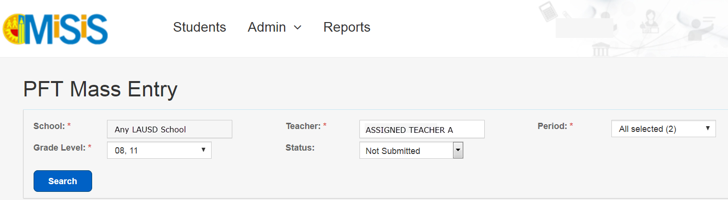

**1**

**2**

****Navigate the screen using the vertical/horizontal scroll bars/arrows or use the tab key/navigational keys on your keyboard to access all six components. You might have to scroll down to the bottom of the screen to locate the horizontal bar.

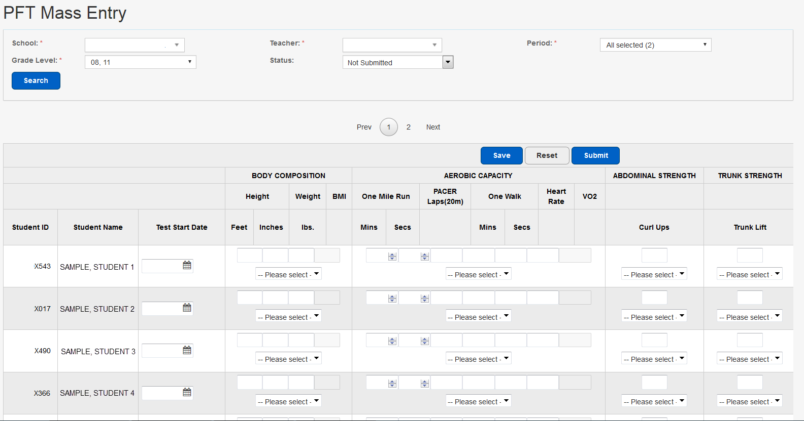

Horizontal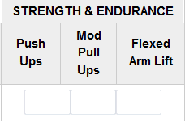

Vertical



The screen will only display ten student records at a time – save any entries before navigating to the next page; otherwise, the system will generate an alert message indicating that the unsaved data will be lost. Use the **Prev 1** / **2 Next** button(s) to display the next ten records.

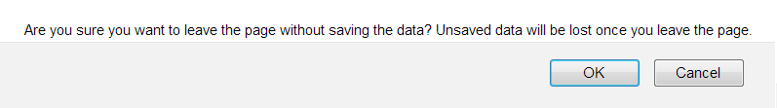

**Step 3** **Click** inside the **Test Start Date** field to display the calendar icon to select the test date.

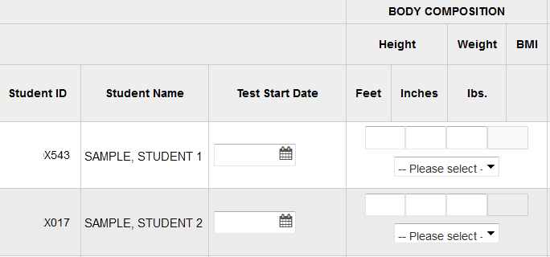

Entry fields

Test components

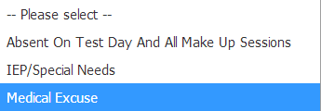

**3**

**Step 4** **Click** in the component’s entry field and **type** a valid value (images shown in the next pages). If the student did not take the test, leave the entry fields blank and select a valid reason from the “**Please select”** drop-down list located under those fields.

* Refer to the valid value range provided or hover the mouse pointer over the entry field to display a tooltip with the valid values for that field.

Body Composition

**Note: Body Composition is not a required test for the 2021-22 school year. Users may save entries on this screen, but the “Submit” button for this screen has been disabled.**

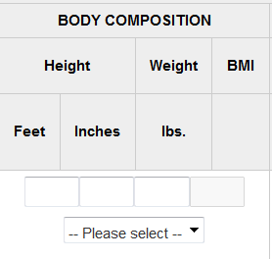

**4**

|  |  |
| --- | --- |
| **Valid Value Range** | |
| **Height** |  |
| **Feet** | Number between 3 - 7 |
| **Inches** | Number between 0 – 11 |
| **Weight lbs.** | Number between 30 – 400 |
| **BMI** | System populated |

The system will generate an error message in red, under the **Search** button, if invalid score values are entered or if a field is left blank. The entry field with the error will be highlighted in red, hover the mouse pointer over the field to display a tooltip with the correct value. The **Test Start Date** field does not display a tooltip.

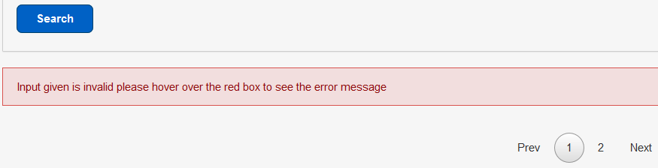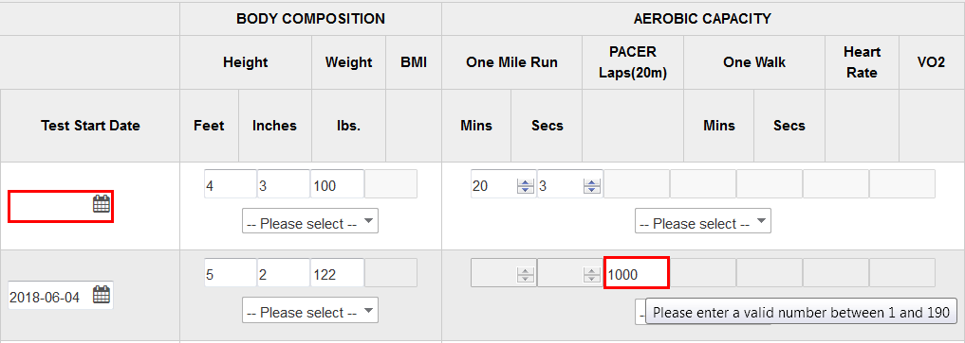

Aerobic Capacity

The aerobic capacity component provides **three test options**; scores can only be entered for one option. As the scores for a test option are being entered, the other options will become disabled. The VO2 field is system generated once the values are saved.

Follow these instructions to correct the data in a field whenever the component has more than one test option: (a) delete the data in the field, enter the correct value(s) and save **or** (b) delete the data in the field, enter the appropriate value(s) in one of the other option fields and save. The Reset button should not be used since it will delete the data from the selected option field but it will keep the other option fields disabled.

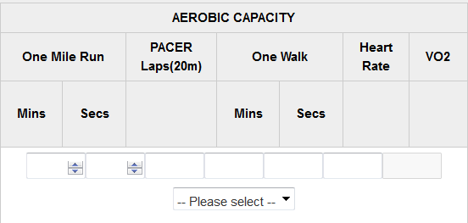

**4**

|  |  |
| --- | --- |
| **Valid Value Range** | |
| **One Mile Run** |  |
| **Mins** | Number between 3 - 59 |
| **Secs** | Number between 0 - 59 |
| **PACER**  **Laps(20m)** | Number between 1 – 190 |
| **One Walk** |  |
| **Mins** | Number between 3 - 59 |
| **Secs** | Number between 0 - 59 |
| **Heart Rate** | Number between 30 - 250 |
| **VO2** | System generated |

Abdominal Strength

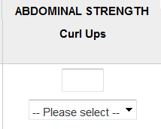

**4**

|  |  |
| --- | --- |
| **Valid Value Range** | |
| **ABDOMINAL STRENGTH** |  |
| **Curl Ups** | Number between 1 – 75 |

Trunk Strength

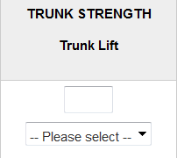

**4**

|  |  |
| --- | --- |
| **Valid Value Range** | |
| **TRUNK STRENGTH** |  |
| **Trunk Lift** | Number less than or equal to 12 |

Strength & Endurance

The strength and endurance component provides **three test options**; scores can only be entered for one option. As the scores for a test option are being entered, the other options will become disabled.

|  |  |
| --- | --- |
|  | **Valid Value Range** |
| **Push**  **Ups** | Number between 1 and 75 |
| **Modified**  **Pull Ups** | Number between 1 and 75 |
| **Flexed**  **Arm Lift** | Number less than or equal to 90 |

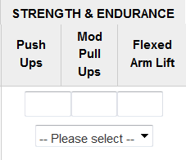

**4**

Flexibility

|  |  |
| --- | --- |
| **Valid Value Range** | |
| **Sit And Reach** |  |
| **Left** | Number less than or equal to 12 |
| **Right** | Number less than or equal to 12 |
| **Shoulder Stretch** |  |
| **Left** | Y or N |
| **Right** | Y or N |

The flexibility component provides **two test options**; scores can only be entered for one option. As the scores for a test option are being entered, the other option will become disabled.

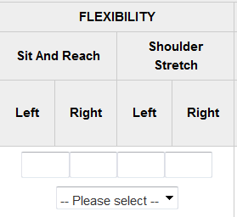

**4**

**Step 5** **Click** in the checkbox located to the far right of the student record, under the **Submit All** header, to place a checkmark prior to saving/submitting the scores.

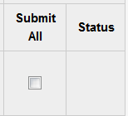

**5**

The following error message will display if a checkmark is not placed in the checkbox for the record actively being worked on.



If a checkmark is accidentally placed in the **Submit** **All** checkbox for a student that displays results (passor fail) from a previous test, the system will highlight the datafield in red; correct the error by removing the checkmark and clicking the save button again.

The **Status** field will be automatically populated with the icon for the overall results (pass or fail).

**Step 6** **Click** the **Save** button. You may continue working on them and save as needed. The **Reset** button will restore the data to the last save/update.



**6**

**Step 7** **Click** the **Ok** button of the alert message generated.

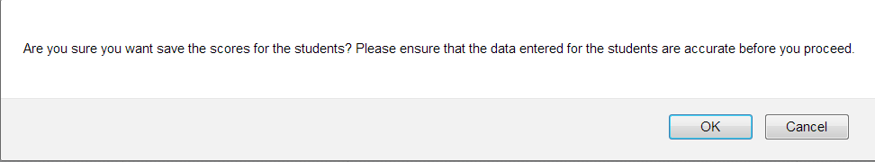

**7**

A **“Data Saved”** confirmation message will be posted under the student ID.

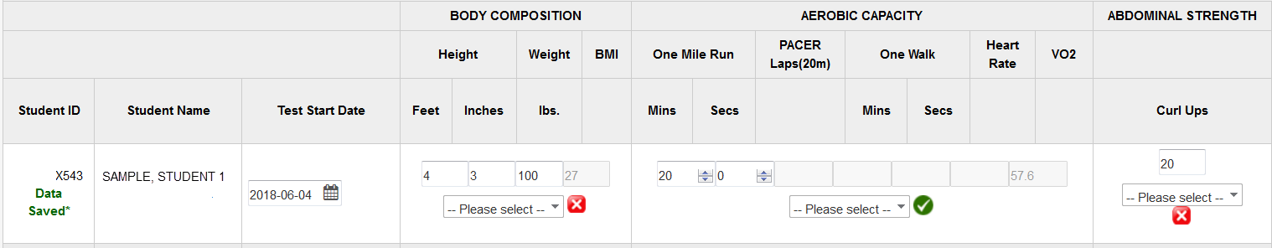

**Step 8** **The Submit button is disabled. Clicking on the Save button will save all entered values.**

**8**

